
Arizona Toy Dog Fancier
Club


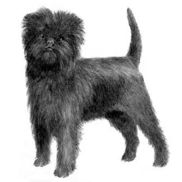
Application for Membership



All applications must be sent to the ATDF Membership Chairperson and be accompanied by the appropriate annual dues. Regular individual membership of 18 years and older $15. Junior membership is $10 under 18 years old. Junior membership carries all privileges of Regular membership except voting rights. Annual dues shall become due and payable on the first day of January. If a prospective member is accepted prior to January 1st, the dues accompanying the application shall be prorated by the month(s) remaining in the current year. I do hereby make application for membership of the above organization and if accepted as a member, do hereby agree to abide by all the rules, regulations, and by-laws of the Club.
Yorkshire Terrier
Affenpinscher
a
Email to the Arizona Toy Dog Fanciers Secretary at starquestpaps@yahoo.com Susan Edwards. Submit dues of $16 via PayPal to ATDF2025@gmail.com
Toy Fox Terrier
Biewer Terrier


Notice: Applications must be endorsed by (2) two members in good standing who, (a) have been ATDF members for two (2) years or more, and (b) who have known the applicant two (2) years or more. Applications must be accompanied by the correct dues amount in US currency. Applicants must answer all questions.
Please fill in all information below
Choose Regular Membership Junior Membership
Brussels Griffon
Silky Terrier
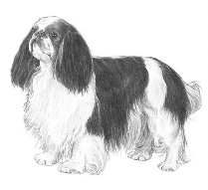
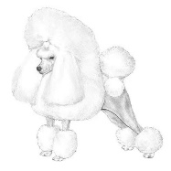





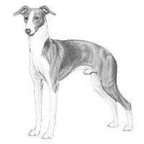

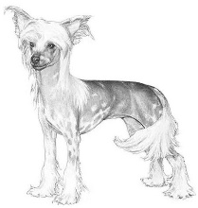


Check all that apply: Breeder Exhibitor Obedience Judge Handler Agility
English Toy Spaniel
Poodle Toy
Russian Toy
Bolonka
Russian Tsvetnaya

Pug
Shih Tzu
Havanese
Chinese Crested
Chihuahua
Cavalier King Charles Spaniel

Name: |  |  |  | Home# |  |  |  |  |  |  |  | Cell:
Address:
Email: |  |  |  |  |  | Occupation:
Kennel Name: |  |  |  |  |  | Website:
Do you participate in Rescues? | Yes No
Have you ever been declined a membership in any dog club? |  |  |  |  |  |  |  |  | Yes No
Are you a member in good standing with AKC? |  |  |  |  | Yes No
Have you ever been suspended from the AKC? |  |  |  |  | Yes No
If yes, list why, when, and how long?
Sponsor Reference #1
Name: |  |  |  |  |  |  |  | Cell:
How long have you known the applicant?
Have you been to the applicant’s home? Yes No
Have you met the applicant in person? Yes No
Why do you recommend the applicant for membership:
Sponsor Signature |  |  |  |  |  |  |  |  |  |  | Date:
Sponsor Reference # 2
Name: |  |  |  |  |  |  |  | Cell:
How long have you known the applicant?
Have you been to the applicant’s home? Yes No
Have you met the applicant in person? Yes No
Why do you recommend the applicant for membership:
Sponsor Signature |  |  |  |  |  |  | Date:
DO NOT WRITE BELOW
Dates Application Read: |  | 1st : |  |  |  |  |  |  |  | 2nd :
Date of Action: |  |  | Approved Declined
President’s Signature:
Secretary’s Signature:


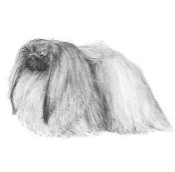


By signing below, I have received a copy of “AKC Sportsmanship and Civility, and agreed to abide by those rules, and my application information is correct.
Italian Greyhound
Pomeranian
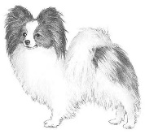
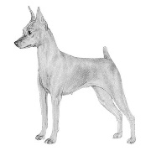
__________________________________________________________________ Date

Miniature Pinscher
Manchester Terrier
Pekingese
Maltese
Japanese Chin
Papillon

